MySQL Server is installed, 25 packages total (mysql-server, mysql-client, plus Perl dependencies it needs for logrotate/admin scripts),
Once it finishes, run:
```bash
sudo systemctl status mysql
```
to confirm it's active, then secure the installation:
```bash
sudo mysql_secure_installation
```
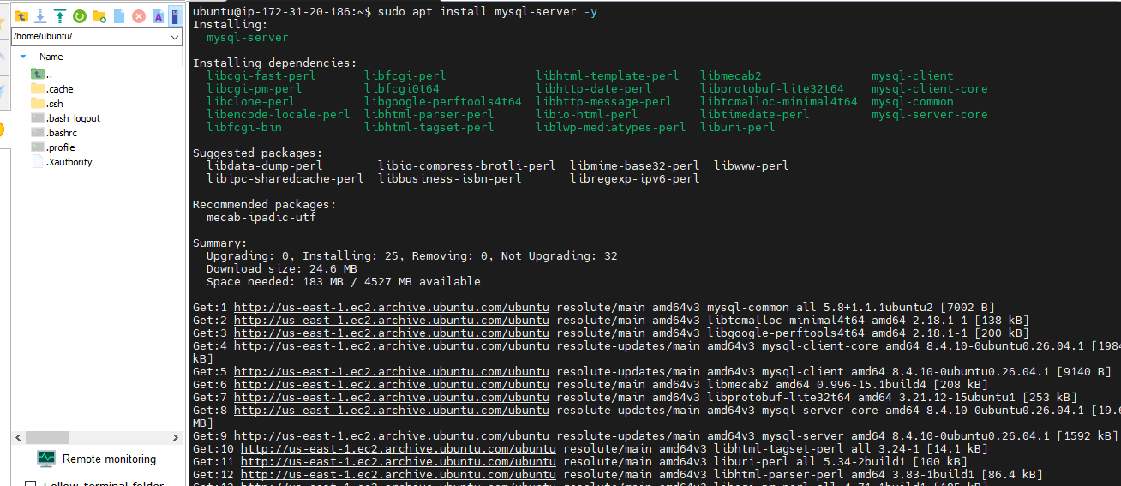

MySQL is active (running) — status shows "Server is operational," enabled on boot, no errors.
Next, I secured it:
```bash
sudo mysql_secure_installation
```
Once that's done, install PHP:
bash
```bash
sudo apt install php libapache2-mod-php php-mysql -y
sudo systemctl restart apache2
```

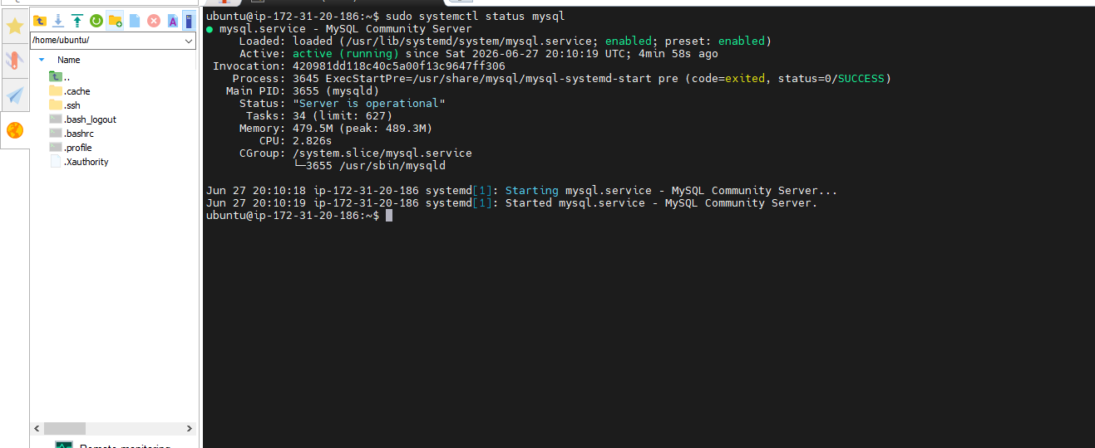

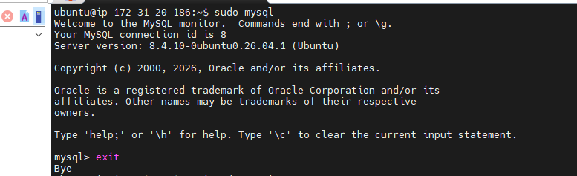

I am running through mysql_secure_installation. A couple of notes on what happened:
- I entered "8" for password validation level, which is invalid (only 0/1/2 are accepted), it reprompted, and I correctly entered 2 (STRONG).
- Important: it says "Skipping password set for root as authentication with auth_socket is used by default." This means root login is tied to OS-level authentication (auth_socket), not a password
- It asked about removing the anonymous user, I said y.
- Remove anonymous users → y
- Disallow root login remotely → y
- Remove test database → y
- Reload privilege tables → y

